**Problem-1: Box**

import java.util.Scanner;

public class Box {

private float width,height,length;

Box(){

}

Box(float w, float l, float h){

width =w;

height =h;

length=l;

}

public float getWidth() {

return width;

}

public float getHeight() {

return height;

}

public float getLength() {

return length;

}

public void setWidth(float w) {

width = w;

}

public void setHeight(float h) {

height = h;

}

public void setLength(float l) {

length = l;

}

public float getArea(){

return width*length;

}

public float getVolume(){

return width*height*length;

}

public static void main(String[] args) {

Scanner in = new Scanner(System.in);

System.out.println("\t---For 1st BOX (User Input)--- ");

System.out.print("Enter Length: ");

float a= in.nextFloat();

System.out.print("Enter Width: ");

float b= in.nextFloat();

System.out.print("Enter Height: ");

float c= in.nextFloat();

Box b1 = new Box(a,b,c);

float area =b1.getArea();

float vol =b1.getVolume();

System.out.println(" Area of Box 1: " + area+ " square unit" +

"\nVolume of Box 1: " + vol + " cubic unit");

System.out.println("\n\t----For 2nd BOX (Input defined)---- ");

Box b2= new Box();

b2.setHeight((float)5.5);

b2.setLength((float)10);

b2.setWidth((float)5.6);

System.out.println("Length: " + b2.getLength()+" units, Width: "+ b2.getWidth() +

" units, Height: " + b2.getHeight() + " units" +"\n Area of box 2: "

+ b2.getArea()+ " square unit" +"\nVolume of box 2: " + b2.getVolume()

+ " cubic unit\n" );

}

}

**OUTPUT:**

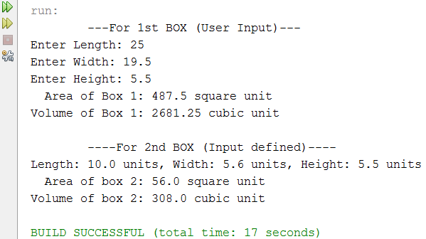

**Problem- 2: Number Converter**

import java.util.Scanner;

public class NumberConverter {

private int number;

NumberConverter(){

}

NumberConverter(int n){

number=n;

}

public int getNumber(){

return number;

}

public void setNumber(int n){

number = n;

}

public String toDecimal(){

String s = ""+number;

return s;

}

public String toHex(){

return Integer.toHexString(number);

}

public String toBinary(){

return Integer.toBinaryString(number);

}

public String toOctal(){

return Integer.toOctalString(number);

}

public static void main(String[] args) {

Scanner sc = new Scanner(System.in);

System.out.print("Enter an Integer: ");

int a = sc.nextInt();

NumberConverter c1 = new NumberConverter(a);

String b1 = c1.toBinary();

String o1 = c1.toOctal();

String d1 = c1.toDecimal();

String h1 = c1.toHex();

System.out.println("You have entered: " + c1.getNumber() + "\n**Different forms**" + "\nBinary:: " + b1 + "\nOctal:: " + o1 + "\nDecimal:: " + d1+ "\nHexadecimal:: " + h1);

NumberConverter c2 = new NumberConverter();

System.out.println("\n\n:::Another number:::");

c2.setNumber(13);

System.out.println("My Number: " + c2.getNumber() + "\n**Different forms**" + "\nBinary:: " + c2.toBinary() + "\nOctal:: " + c2.toOctal() + "\nDecimal:: " + c2.toDecimal()+ "\nHexadecimal:: " + c2.toHex());

}

}

**OUTPUT:**

